MEMORANDUM

From: Jehyeon Lee

Date: 04/11/2024

Subject: The technological advances' effects on GDP growth for both developed and undeveloped countries.

Introduction:

Economic development is the main subject that all nations take very seriously. Economic development is an important way to make the nation strong and bring better well-being to people in the nation. This is why the policymakers of each nation take it seriously and work hard to develop their nations economically. In this matter, it is important to know what makes a nation’s economy grow. One commonly adopted assumption is that technological growth leads to a nation’s economic growth. In this paper, we will delve if this assumption is true or not. Using indicators called GDP which is commonly accepted as a representation of a country’s economic status, we are going to see how economic growth is related to technological growth.

Data Description:

To accomplish our statistical experiments, we should collect data that includes technological status and GDP. To do this, we used “Penn World Table” data which contains the nations’ real GDP,  relative levels of income, output, input, and productivity, covering 183 countries between 1950 and 2019. This data is very useful to track how the GDP of the nations in the world changes over time.

To retrieve the data for technological status, we used NBER data which contains an unbalanced panel dataset with information on the specific amount of how well the nations adopted over 100 technologies in more than 150 countries since 1800. we used this data as an indicator of each country's technological status and we will track how technological adoption and advancements of each country change over time.

These two datasets are not useful for themselves. We had to merge two datasets and make some modifications to use them for our research. We added variables for GDP growth and technological variables growth which are calculated according to variables of each year. The formula is like this “(value of current year) / (value of previous year) - 1 ) x 100”. This represents the percentage of Growth for each variable.

Since we also examined whether developed countries have higher GDP and technological growth overall, we created a variable “developed” which is a dummy variable. The developed countries in this research only include (France, Germany, Italy, Japan, the United Kingdom, and the United States of America). Other countries are classified as developing countries with 0 value of the “developed” variable. We only used 5 selected technologies for our research. The variables are radio (radio), telephone(telephone), tv(tv), car (vehicle_car), and electricity production (elecprod). We only used data from 1970 to 2000.

The source of data will be found below:

Penn World Table data:  <https://www.rug.nl/ggdc/productivity/pwt/>

NBER data: <https://data.nber.org/data-appendix/w15319/>

* Empirical Analysis:

First of all, we have examined how GDP growth differs between developed and undeveloped countries. Then, we examined all the technology's growth to see how it is related and differs from developed countries' status. You can see the results in the below table and graph.

|  |  |  |  |  |  |  |
| --- | --- | --- | --- | --- | --- | --- |
| **Estimated AveragenGrowth Rates** | | | | | | |
| **developed** | **GDP** | **radio** | **telephone** | **tv** | **vehicle car** | **electricity production** |
| **0** | **2.45%** | **6.77%** | **8.10%** | **14.98%** | **3.33%** | **7.14%** |
| **1** | **2.73%** | **2.62%** | **5.85%** | **3.33%** | **4.10%** | **3.21%** |

(Table 1)

(Graph 2)

As you can see from Table 1 and Graph 1, the GDP growth is higher for developed countries and lower for developing countries. From the graph1, we can see that the GDP growth is not only higher on average but also higher across years. This would represent there is something special about the developed countries that contribute to their GDP growth.

We can easily come up with the assumption that developed countries have better technological infrastructures which contributes the GDP growth. This is linked to the idea that the growth of technology would have correlated to the GDP growth. Let’s see if this assumption can be true from Table 1. You can see that all of the 5 technologies growth of radio, telephone, tv, vehicle car, and electricity production are higher in developing countries. This can be seen that GDP growth is negatively correlated with Technological growth. However, we can make a different assumption, either the growth of the technology decreases GDP growth or the developing countries steadily increase the technological infrastructure earlier than the developing countries, and these infrastructures are positively affecting the GDP growth of the nations.

To examine this, we had to approach it differently. Since we have time variables and each technological growth and GDP are related to time, we used fixed effects to take away the time variable effects. We used the Fixed effects approach that regresses GDP growth on all 5 technologies. The result is described in Table 2 below. The graph of growth for all the variables including GDP is shown in Graph 2.

|  |  |  |  |  |
| --- | --- | --- | --- | --- |
| **Result of GDP Growth Regressed on Technological Growth** | | | | |
| **Variables** | **Coeeficient** | **Std.err** | **t** | **p > |t|** |
| radiogwt | 0.047 | 0.025 | 1.890 | 0.060 |
| telephonegwt | 0.074 | 0.024 | 3.100 | 0.002 |
| tvgwt | 0.002 | 0.003 | 0.750 | 0.454 |
| vehicle_cargwt | 0.022 | 0.015 | 1.470 | 0.143 |
| elecprodgwt | 0.100 | 0.019 | 5.380 | 0.000 |
| _cons | -0.133 | 0.331 | -0.400 | 0.687 |

(Table 2)

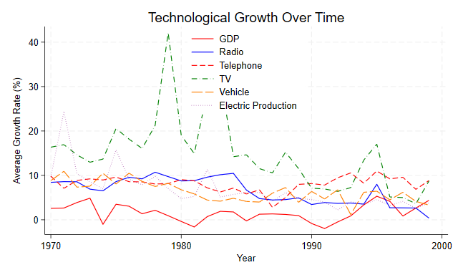(Graph 2)

As you can see from the Graph above, we can see that the GDP growth increases when technological adoption increases. Between 1990 and 2000, you can see that GDP and Technological growth rose and fell similar period. We can assume there is still a correlation between technological growth and GDP growth.

Let’s look at table 2 where we regress in the fixed effects method to see more precisely the relationship. The GDP growth is positively correlated to all the technological (radio, telephone, TV, car, electricity production) growth. The coefficients of radio, TV, and car are not statistically significant. However, telephone and electricity production are statistically significant. Even though some of the variables are not statistically significant, it is quite meaningful that all the variables are positively correlated to GDP and this shows that technological growth has a positive impact on GDP growth.

Conclusion:

From this research, we could find that there is a positive correlation between technology and GDP growth. Since we found that developing countries have lower GDP growth than developed countries, we could see that technological growth is affecting not only present but also future GDP growth. Since we found a positive correlation, we can assume there is possibly an impact of technological growth on GDP growth. Some limitations we have faced are that we found a strong correlation but haven’t found if this is causation actually. Further research on this is needed to conclude that GDP growth is impacted by technological growth. We could find data like how the R&D investment of each country results the GDP growth and how it is different for nations with technology-focused industries to have higher GDP compared to countries with basic industries.